**NEC Codes Excel Conversion To Access**

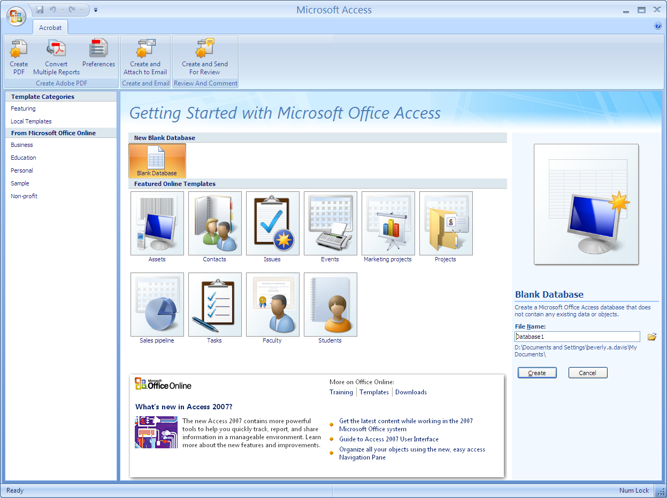

* Select Blank Database
* Enter File Name
* Select Create
* 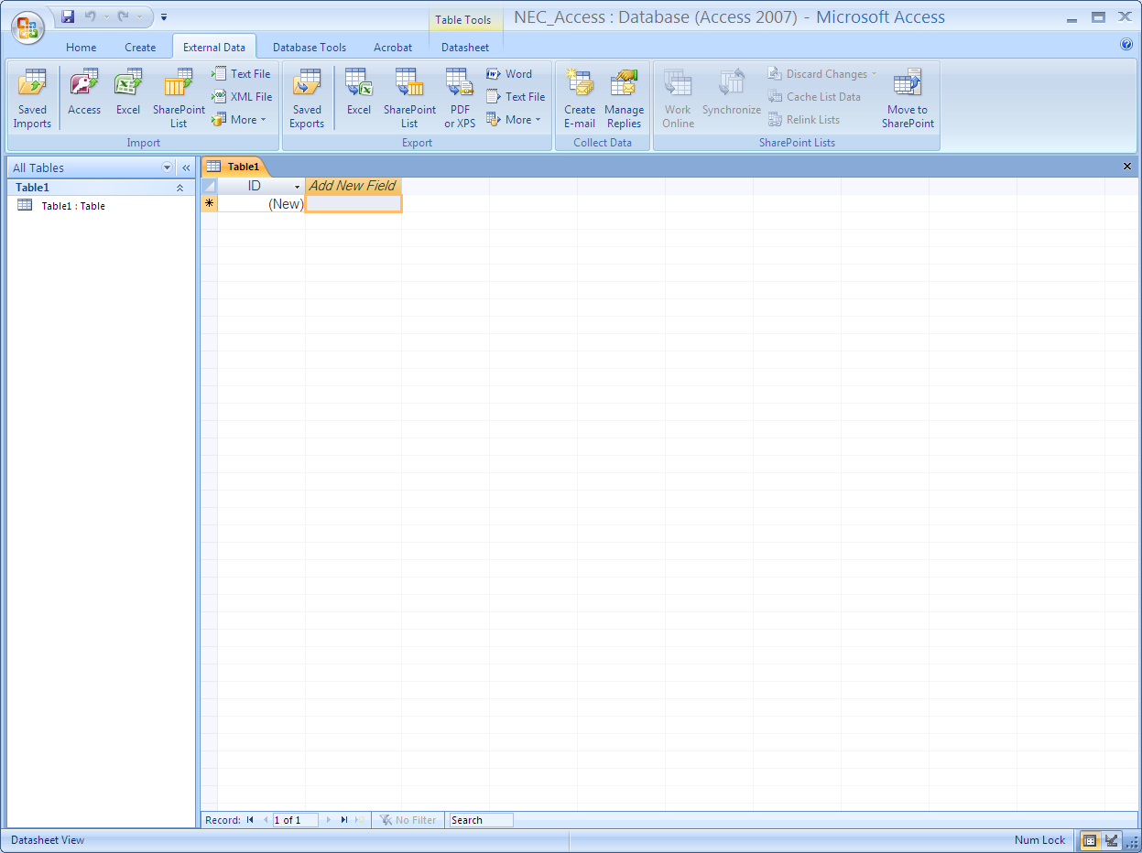Select External Data tab
* Select Excel (to import spreadsheet)

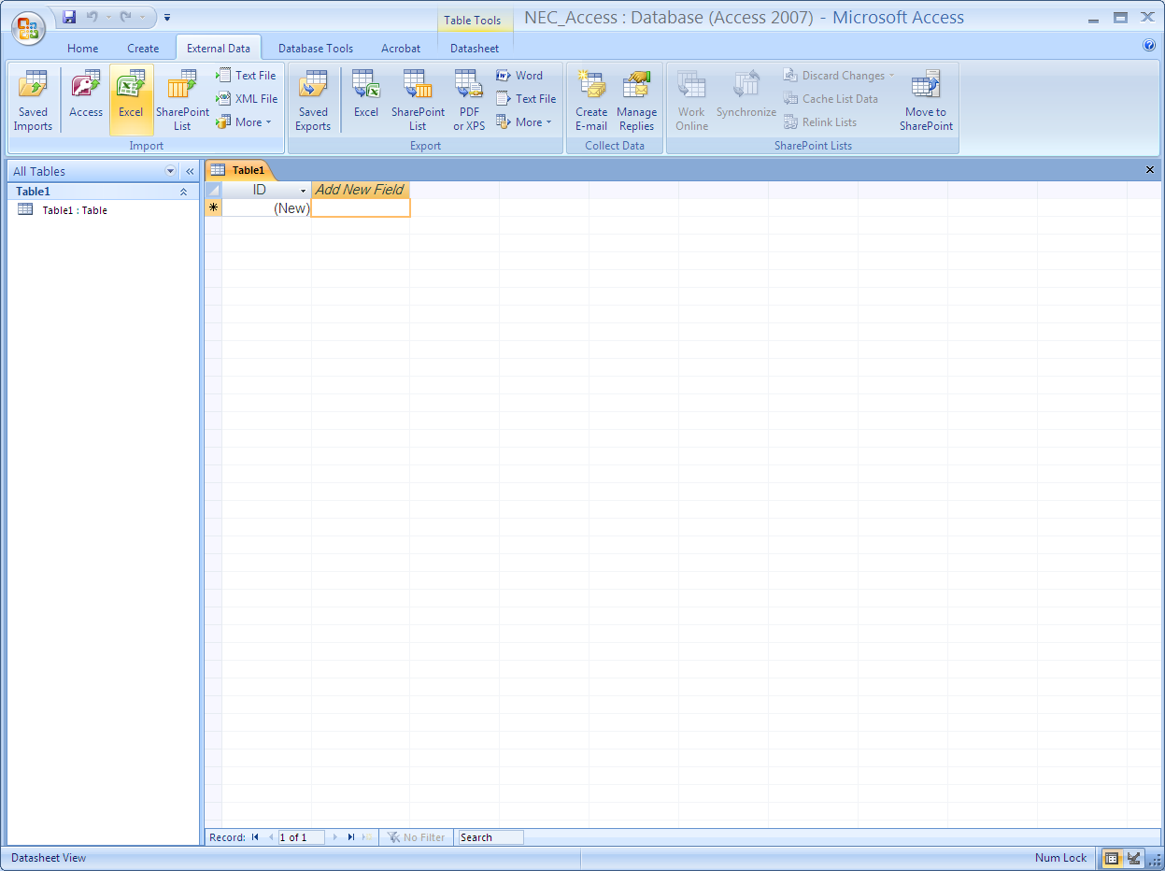

* Enter NEC Excel file location
* 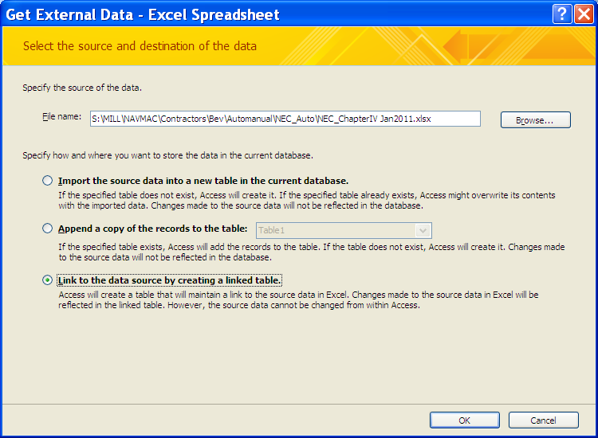Select Option for how & where to store
* Import moves all data to location
* Link allows data to flow quicker if store on system with spreadsheet; if over network speed decreases.



* Select Open
* 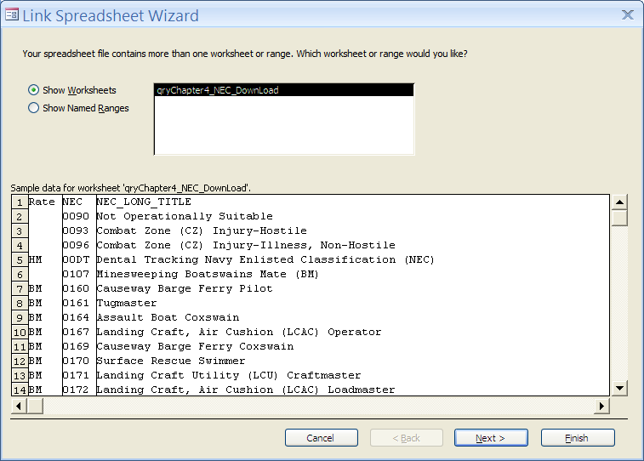Select Next

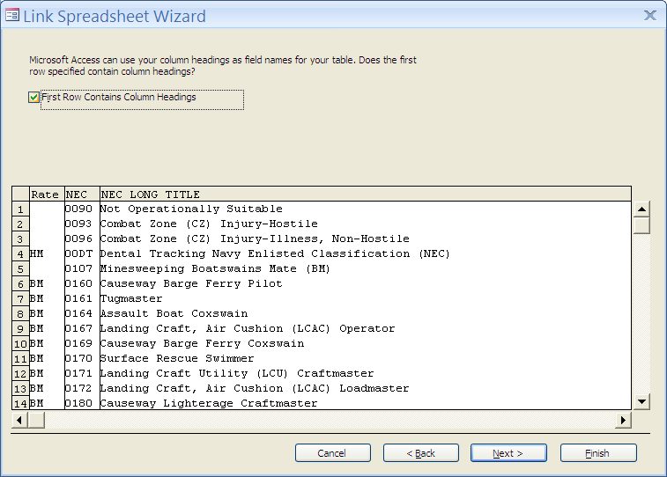

* Select First Row option
* Select Next
* 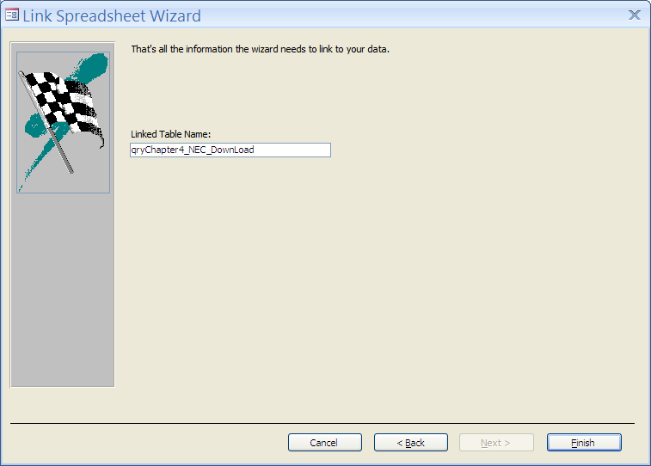Select Finish

Link Completed

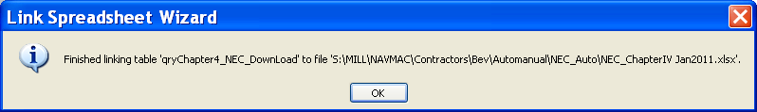

* Select OK

___________________________________________________________________**Creation of Queries**

* Select Create tab
* Select Query Wizard
* Select Simple Query Wizard
* Select OK

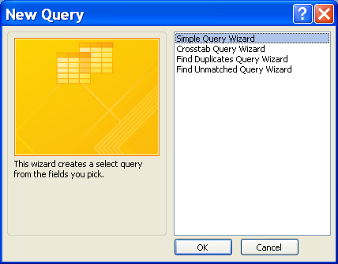



* Select Open
* Select Table
* Select All Available Fields (>>)

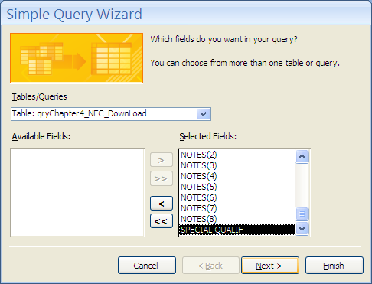

* Select Next

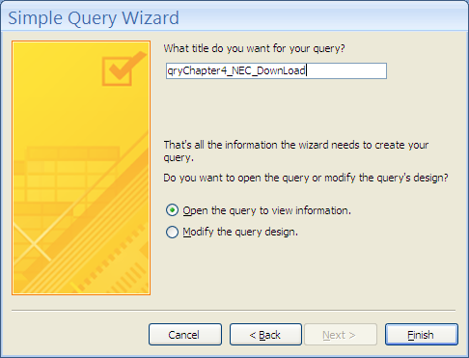

* Name Query
* Select Finish

**Table (Fields) Relationships**

